Network Video Recorder
Quick Start Guide

Version 3.5.0
Table of Contents
1 Hardware Installation and Connection 1
1.1 Check Unpacked NVR 1
1.2 About Front Panel and Rear Panel 1
1.3 After Remove the Chassis 1
1.4 HDD Installation 1
1.5 Front Panel 2
1.6 Rear Panel 3
2 GUI Operation 6
2.1 Login 6
2.2 Remote Device 7
2.3 System Setting-Schedule 10
2.4 Realtime Playback 11
3 Web Operation 12
3.1 Network Connection 12
3.2 Login 13
3.3 Main Window 14
3.3.1 LAN Login 14
3.3.2 WAN Login 14
Appendix Toxic or Hazardous Materials or Elements 15

Welcome
Thank you for purchasing our network video recorder!
This quick start guide is designed to be a reference tool for your system.
Please open the accessory bag to check the items one by one in accordance with the list below. Contact your local retailer ASAP if something is missing or damaged in the bag.

Important Safeguards and Warnings
1．Electrical safety
All installation and operation here should conform to your local electrical safety codes.
The product must be grounded to reduce the risk of electric shock.
We assume no liability or responsibility for all the fires or electrical shock caused by improper handling or installation.
2．Transportation security
Heavy stress, violent vibration or water splash are not allowed during transportation, storage and installation.
3．Installation
Keep upwards. Handle with care.
Do not apply power to the NVR before completing installation.
Do not place objects on the NVR
4．Qualified engineers needed
All the examination and repair work should be done by the qualified service engineers.
We are not liable for any problems caused by unauthorized modifications or attempted repair.
5．Environment
The NVR should be installed in a cool, dry place away from direct sunlight, inflammable, explosive substances and etc.
This series product shall be transported, storage and used in the specified environments.

6. Accessories
Be sure to use all the accessories recommended by manufacturer.
Before installation, please open the package and check all the components are included.
Contact your local retailer ASAP if something is broken in your package.

7. Lithium battery
Improper battery use may result in fire, explosion, or personal injury!
When replace the battery, please make sure you are using the same model!

Before your operation please read the following instructions carefully.
- Installation environment
- Keep away from extreme hot places and sources；
- Avoid direct sunlight；
- Keep away from extreme humid places；
- Avoid violent vibration；
- Do not put other devices on the top of the NVR；
- Be installed in well ventilated place; do not block the vent.

- Accessories
Check the accessories after opening the box：
- Please refer to the packing list in the box *

Hardware Installation and Connection
Note: All the installation and operations here should conform to your local electric safety rules.

Check Unpacked NVR
When you receive the NVR from the forwarding agent, please check whether there is any visible damage. The protective materials used for the package of the NVR can protect most accidental clashes during transportation. Then you can open the box to check the accessories.
Please check the items in accordance with the list (Remote control is optional). Finally you can remove the protective film of the NVR.

About Front Panel and Rear Panel
For detailed information of the function keys in the front panel and the ports in the rear panel, please refer to the User’s Manual included in the resource CD.
The model label in the front panel is very important; please check according to your purchase order.
The label in the rear panel is very important too. Usually we need you to represent the serial number when we provide the service after sales.

After Remove the Chassis
Please check the data cable, power cable, COM cable and main boar cable connection is secure or not.

HDD Installation
Important：
Please turn off the power before you replace the HDD.
The pictures listed below for reference only
You can refer to the User’s Manual for recommended HDD brand. Please use HDD of 7200rpm or higher. Usually we do not recommend the PC HDD.
Please note the following steps based on our NVR52 series product. For detailed operation instruction, please refer to the User’s Manual included in the resources CD.
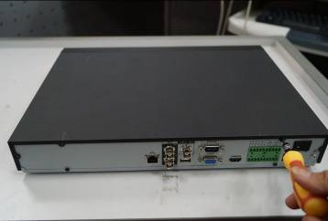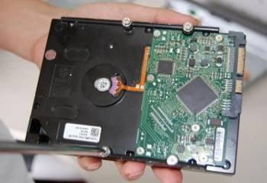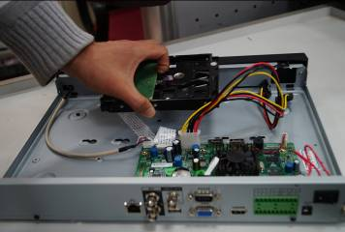
1. Loosen the screws of the upper cover and side panel.
2. Fix four screws in the HDD (Turn just three rounds).

3. Place the HDD in accordance with the four holes in the bottom.

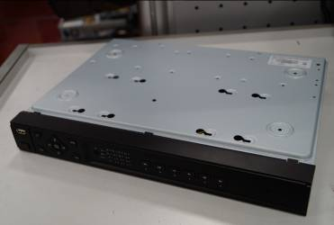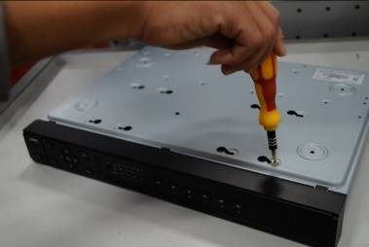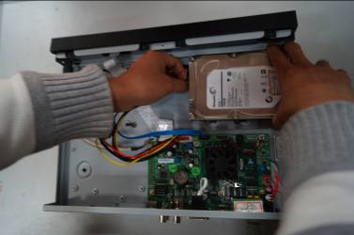
4. Turn the device upside down and then turn the screws in firmly.
in the chassis.
5. Fix the HDD firmly.

6. Connect the HDD cable and power cable.

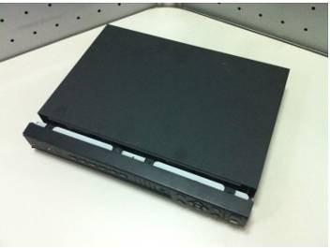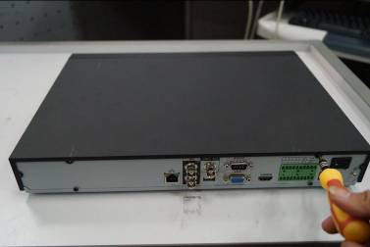
7. Put the cover in accordance with the clip and then place the upper cover back.
8. Secure the screws in the rear panel and the side panel.

Front Panel
Please note the following contents based on our NVR52 series product. For detailed operation instruction, please refer to the User’s Manual included in the resources CD.
The front panel is shown as in Figure 1-1.
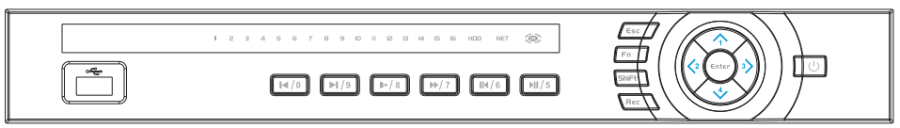
Figure 1-1
Please refer to the following sheet for front panel button information.
Name | Icon | Function
Power button |  | Power button, press this button for three seconds to boot up or shut down NVR.
USB2.0 port |  | To connect USB storage device, USB mouse, burner and etc.
Up/1  Down/4 | , | - Activate current control, modify setup, and then move up and down.  - Change setup. Increase/decrease numeral.  - Assistant function such as PTZ menu.
Left/2  Right/3 | ,  | Shift current activated control, move left or right.  When playback, click these buttons to control playback bar.
Play/Pause /5 |  | In normal playback click this button to start/pause playback.
Reverse/Pause/6 |  | In normal playback or pause mode, click this button to reverse playback.
Fast play/7 |  | Various fast speeds and normal playback.
Slow play/8 |  | Multiple slow play speeds or normal playback.
Play Next/9 | │ | In playback mode, playback the next video
Play previous/0 | │ | In playback mode, playback the previous video.
HDD abnormal indication light | HDD | HDD error occurs or HDD capacity is below specified threshold value, the light becomes red to alert you.
Network abnormal indication light | Net | Network error occurs or there is no network connection, the light becomes red to alert you.
Record light | 1-16 | System is recording or not. It becomes on when system is recording.
IR Receiver | IR | It is to receive the signal from the remote control.
ESC | Esc | - Go to previous menu, or cancel current operation.  - When playback, click it to restore real-time monitor mode.
Enter | Enter | - Confirm current operation.  - Go to default button.  - Go to menu.
Assistant | Fn | - One-window monitor mode, click this button to display assistant function: PTZ control and image color.  - Backspace function: in numeral control or text control, press it for 1.5seconds to delete the previous character before the cursor.  - In motion detection setup, working with Fn and direction keys to realize setup.  - In text mode, click it to switch between numeral, English character (small/capitalized) and etc.  - Realize other special functions.
Shift | Shift | - In textbox, click this button to switch between numeral, English (Small/Capitalized), donation and etc.  - During tour process, enable/disable tour.  - Click it to auto adjust resolution after device booted up.
Record | Rec | Manually stop/start recording, working with direction keys or numeral keys to select the recording channel.

Rear Panel
Please note the following contents based on our NVR52 series product. For detailed operation instruction, please refer to the User’s Manual included in the resources CD.
The rear panel is shown as below. See Figure 1-2.
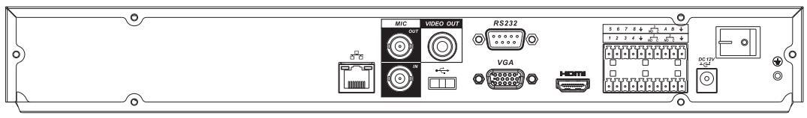
Figure 1-2
Please refer to the following sheet for detailed information.
 | Port Name | Connection | Function
USB2.0 | USB2.0 port. | / | Connect to USB2.0 mouse.
 | Network port | / | 10M/100M/1000Mbps self-adaptive Ethernet port. Connect to the network cable.
RS232(RS-422) | RS232 debug COM. | / | It is for general COM debug to configure IP address or transfer transparent COM data.
HDMI | High Definition Media Interface | / | High definition audio and video signal output port. It transmits uncompressed high definition video and multiple-channel data to the HDMI port of the display device.
VGA | VGA video output port | VGA | VGA video output port. Output analog video signal. It can connect to the monitor to view analog video.
1-8 | Alarm input port 1-8. | I/O port | - There are two groups. The first group is from port 1 to port 4; the second group is from port 5 to port 8. They are to receive the signal from the external alarm source. There are two types; NO (normal open)/NC (normal close).  - When your alarm input device is using external power, please make sure the device and the NVR have the same ground.
 | Alarm input port ground end | I/O port | Alarm input ground end.
NO1～NO3 | Alarm output port 1～3 | I/O port | - 3 groups of alarm output ports. (Group 1：port NO1～C1,Group 2:port NO2～C2,Group 3:port NO3～C3）).Output alarm signal to the alarm device. Please make sure there is power to the external alarm device.  - NO：Normal open alarm output port.  - C：Alarm output public end.
C1～C3 | Alarm output port 1～3 | I/O port
A | RS485 (RS-485) communication port | I/O port | RS485_A port. It is the cable A. You can connect to the control devices such as speed dome PTZ.
B | RS485 (RS-485) communication port | I/O port | RS485_B.It is the cable B. You can connect to the control devices such as speed dome PTZ.
 | Power input port | / | Input 12V DC.
Power button |  | / | Power on/off button.
VIDEO OUT | Video input port | / | CVBS output
MIC IN | Audio input port | / | Bidirectional talk input port. It is to receive the analog audio signal output from the devices such as mike phone, pickup.
MIC OUT | Audio output port | / | Audio output port. It is to output the analog audio signal to the devices such as the sound box.  - Bidirectional talk output.  - Audio output on 1-window video monitor.  - Audio output on 1-window video playback.

GUI Operation
Connect the device to the monitor and then connect a mouse and power cable. Click the power button at the rear panel and then boot up the device to view the video output. You can use the mouse to implement some GUI operation.

Login
After device booted up, the system goes to startup wizard interface. See Figure 2-3
Click Cancel or Next Step button, you can see system goes to login interface.
Tips
- Check the box Startup button here, system goes to startup wizard again when it boots up the next time.
- Cancel the Startup button, system goes to the login interface directly when it boots up the next time.
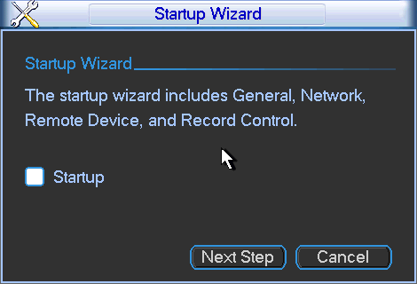
Figure 2-3
Click Cancel button or Next Step, you can see the login interface. Please input user name and password. See Figure 2-4.
System consists of four accounts:
- Username: admin. Password: admin.
- Username: 888888. Password: 888888.
- Username: 666666. Password: 666666.
- Username: default. Password: default.
You can use USB mouse to input. Click to switch between numeral, English character (small/capitalized) and denotation.
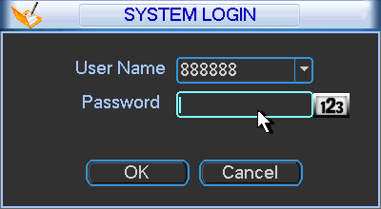
Figure 2-4
Important:
For security reason, please modify password after you first login.
Within 30 minutes, three times login failure will result in system alarm and five times login failure will result in account lock!

Remote Device
From Mani menu->Remote device or right click mouse on the preview interface and then select remote device item, you can see the following interface. See Figure 2-5.
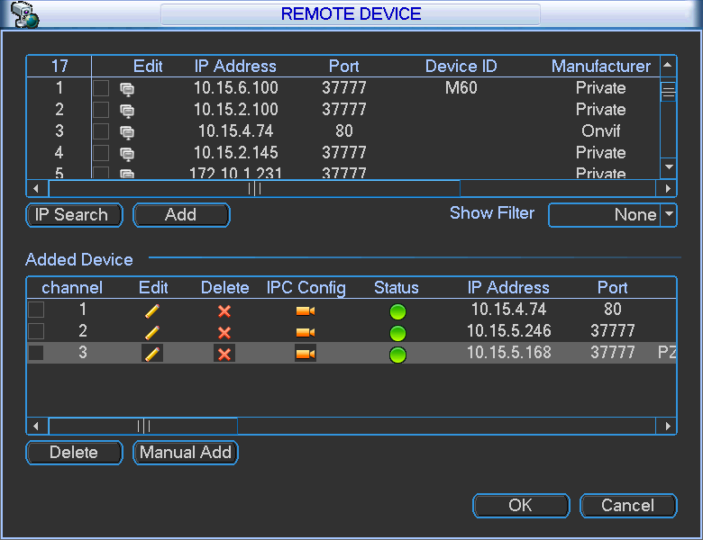
Figure 2-5
Tips
In the preview interface, for the channel of no IPC connection, you can click the icon “+” in the centre of the interface to quickly go to the Remote Device interface. See Figure 2-6.
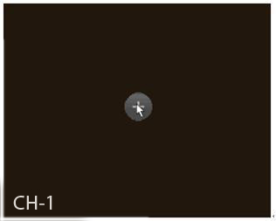
Figure 2-6
Click IP search button, you can view the searched IP addresses at the top pane of the interface.
Double click an IP address or check one IP address and then click Add button, you can add current device to the bottom pane of the interface. System supports batch add function.

Click Manual Add button, you can add a device directly. Here you can set TCP/UPD/auto connection mode. The default setup is TCP. See Figure 2-7.
Important
Please note the manual add function is for Dahua, Panasonic, Sony, Dynacolor, Samsung, AXIS, Arecont, ONVIF and Custom. When the type is the custom, you can just input URL address, user name and password connect to the network camera without considering network camera manufacture. Please contact your network camera manufacturer for the URL address.
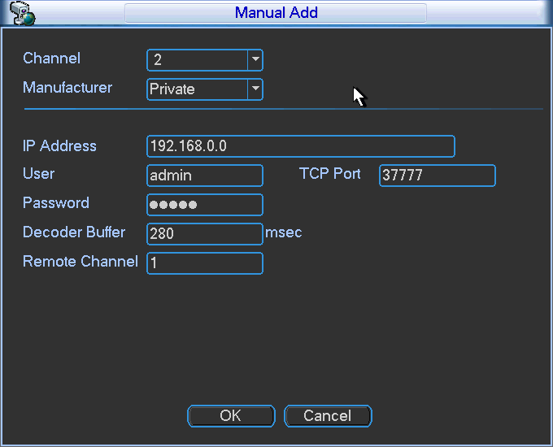
Figure 2-7
Set remote device corresponding information (For some series product only).
- IP search: Click it to search IP address.
- Add: Click it to connect to the selected device and add it to the Added device list. Support Batch add.
- Show filter: You can use it to display the specified devices from the added device.
- IPC config: Double click the on the IPC config column, you can go to the IPC setup interface. See Figure 2-8.
  - Config File: It is to select network camera configuration file. The options include day/night/normal/switch by period. Select switch by period from the dropdown list, you need to set sunrise time and sunset time.
  - Auto iris: This function is for the product of auto iris. You can check the box before enable to turn on this function. The auto iris may change if the light becomes different. When you disable this function, the iris is at the max. System does not add the auto iris function in the exposure control. This function is on by default.
  - Mirror: It is to switch video left and right limit. This function is disabled by default.
  - 3D NR: It is the 3D noise reduction function.
  - Saturation: It is to adjust monitor window saturation. The value ranges from 0 to 100. The default value is 50. The larger the number, the strong the color is. This value has no effect on the general brightness of the whole video. The video color may become too strong if the value is too high. For the grey part of the video, the distortion may occur if the white balance is not accurate. Please note the video may not be attractive if the value is too low. The recommended value ranges from 40 to 60.
  - Brightness: It is to adjust monitor window bright. The value ranges from 0 to 100. The default value is 50. The larger the number, the bright the video is. When you input the value here, the bright section and the dark section of the video will be adjusted accordingly. You can use this function when the whole video is too dark or too bright. Please note the video may become hazy if the value is too high. The recommended value ranges from 40 to 60.
  - Contrast: It is to adjust monitor window contrast. The value ranges from 0 to 100. The default value is 50. The larger the number, the higher the contrast is. You can use this function when the whole video bright is OK but the contrast is not proper. Please note the video may become hazy if the value is too low. If this value is too high, the dark section may lack brightness while the bright section may over exposure .The recommended value ranges from 40 to 60.
  - Sharpness: The value here is to adjust the edge of the video. The larger the value is, the clear the edge is and vice versa. Please note there is noise if the value here is too high. The default value is 1 and the recommended value ranges from 0 to 15.
  - Flip: It is to switch video up and bottom limit. This function is disabled by default. The options include: no flip/flip 180°/clockwise 90°/counter clockwise 90°.
  - Light: Please select from the dropdown list. The option includes: Disable/enable/WDR/HLC. When this function is on, system can automatically expose according to environment so that you can view the darkest section of the video.
  - Scene mode (Profile): It is to set white balance mode. It is to affect the whole video hue. The default setup is auto.
    - Auto: The auto white balance is on. System can auto compensate the color temperature to make sure the vide color is proper.
    - Sunny: The threshold of the white balance is in the sunny mode.
    - Night: The threshold of the white balance is in the night mode.
    - Customized: System supports customized setup.
  - Day/Night mode: Here is to set video color or black and white mode.
    - Color: Camera only outputs color video.
    - Auto: Camera auto selects color or black and white video according to device feature (Video whole brightness or there is any IR light or not.).
    - Black and white: Camera only outputs black and white video.
- Delete: Please select one device in the Added device list and then click it to remove.
- Manual add: Click it to add the IPC manually. The port number is 37777. The default user name is admin and password is admin.
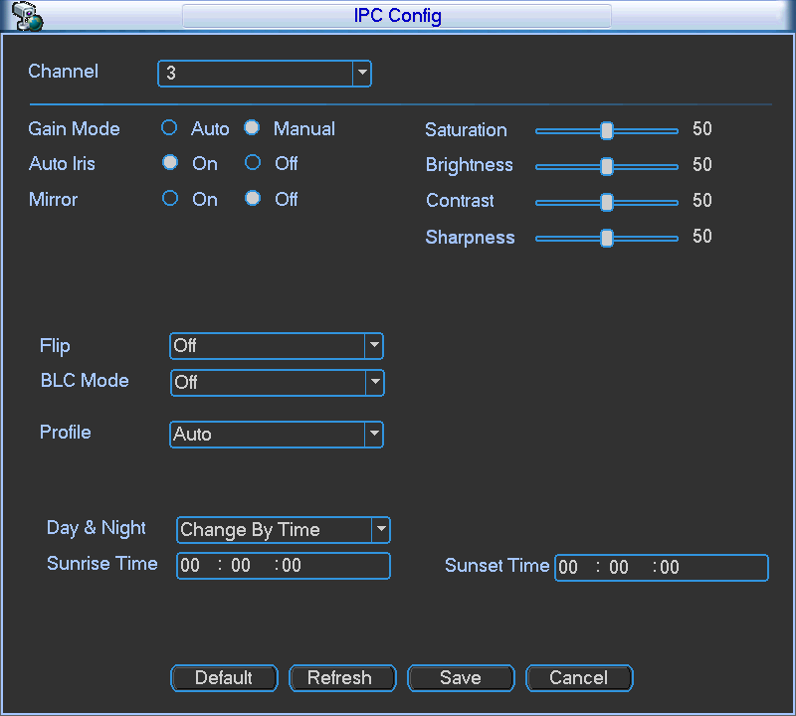
Figure 2-8

System Setting-Schedule
After the system booted up, it is in default 24-hour regular mode. You can set record type and time in schedule interface.
In the main menu, from Setting to Schedule, you can go to schedule menu. See Figure 2-9.
There are total six periods.
- Channel: Please select the channel number first. You can select “all” if you want to set for the whole channels.
- Week day: There are eight options: ranges from Saturday to Sunday and all.
- Pre-record: System can pre-record the video before the event occurs into the file. The value ranges from 1 to 30 seconds depending on the bit stream.
- Redundancy: System supports redundancy backup function. It allows you backup recorded file in two disks. You can highlight Redundancy button to activate this function. Please note, before enable this function, please set at least one HDD as redundant. (Main menu->Advanced->HDD Management). Please note this function is null if there is only one HDD.
- Snapshoot: You can enable this function to snapshoot image when alarm occurs.
- Record types: There are four types: regular, motion detection (MD), Alarm, MD & alarm.
- Holiday: Highlight the button here, the holiday settings in General interface (Please refer to User’s Manual) becomes activated.
Please highlight icon 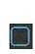 to select the corresponding function. After completing all the setups please click save button, system goes back to the previous menu.
At the bottom of the menu, there are color bars for your reference. Green color stands for regular recording, yellow color stands for motion detection and red color stands for alarm recording. The white means the MD and alarm record is valid. Once you have set to record when the MD and alarm occurs, system will not record neither motion detect occurs nor the alarm occurs.
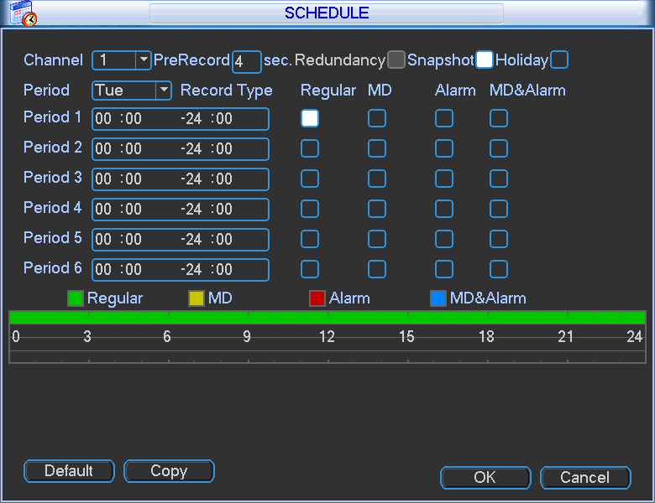
Figure 2-9

Realtime Playback
Preview control interface
Move you mouse to the top centre of the video of current channel, you can see system pops up the preview control interface. See Figure 2-10. If your mouse stays in this area for more than 6 seconds and has no operation, the control bar automatically hides.
1 2 3 4 5 6 7


Figure 2-10
SN | Name | SN | Name | SN | Name
1 | Realtime playback | 2 | Digital zoom | 3 | Real-time backup function
4 | Manual Snap | 5 | Remote device add shortcut | 6 | Bidirectional talk
7 | Close
Realtime playback button is to playback the previous 5-60 minutes record of current channel.
Please go to the Main Menu->General to set real-time playback time.
System may pop up a dialogue box if there is no such record in current channel.

Web Operation
Important
- Slightly difference may be found in the interface due to different series.
- The following operation is based on 16-channel series device. For the 32-channel series product, there is 32-channel option.

This series NVR product support the Web access and management via PC.
Web includes several modules: Monitor channel preview, record search, alarm setup, system configuration, PTZ control, monitor window and etc.

Network Connection
Before web client operation, please check the following items:
- Network connection is right
- NVR and PC network setup is right. Please refer to network setup(main menu->setting->network)
- Use order ping ***.***.***.***(* NVR IP address) to check connection is OK or not. Usually the return TTL value should be less than 255.
- Open the IE and then input NVR IP address.
- System can automatically download latest web control and the new version can overwrite the previous one.
- If you want to un-install the web control, please run uninstall webrec2.0.bat. Or you can go to C:\Program Files\webrec to remove single folder. Please note, before you un-install, please close all web pages, otherwise the un-installation might result in error.
- Current series product supports various browsers such as Safari, firebox browser, Google browser. Device only support 1-channel monitor on the Apple PC.
About PoE address setup, operation and allocation.
  - Insert PoE
After you insert PoE, device may try to set a corresponding IP address of the Switch network adapter. First, system tries to set via arp ping. It then uses DHCP if it finds the DHCP is enabled. After successfully set IP address, system may use Switch to send out broadcast, system thinks the connection is OK when there is any response. Now system is trying to login the newly found IPC. Now please check the interface, you can see the corresponding digital channel is active now. You can see a small PoE icon at the top left corner. You can see the PoE channel, PoE port information and etc from the connection list of the remote device interface (Chapter 5.6.11 in the User’s Manual). For the IP search list, you need to click the IP search to display or refresh.

  - Remove PoE
After you removed PoE, you can see the corresponding digital channel becomes idle (disable). On the remote device interface, it is removed from the connected list. For the IP search list, you need to click the IP search to refresh.

  - After you insert PoE, system follows the principles listed below to map channel.
    - If it is your first time to insert PoE, system can map it to the first idle channel. After map, the channel can memorize the MAC address of the IPC. It is a <Channel>---<IPC mac> map. If current channel does not connect to other device, system can memorize current MAC address, otherwise it can refresh to the newly added device and memorize the <PoE port>---<Channel>.
    - If it is your second time to insert the PoE, system can check the saved MAC address according to <Channel>---<IPC mac> map to make sure current IPC has connected or not. If system finds the previous information and the channel is idle, system can map it to the previously used channel. Otherwise system goes to the next step.
    - Thirdly, according to the <PoE port>---<Channel> map, system can know the previous mapping channel of current PoE port. System can select current channel if it is free. Otherwise, it goes to the next step:
    - Fourthly, system goes to find the first idle channel it can get.
Generally speaking, once you insert PoE, system follow the steps listed above to find the channel available.

  - When you insert PoE, all channels are in use now.
System can pop up a dialogue box for you to select a channel to overwrite. The title of the pop-up interface is the name of the current operation PoE port. In this interface, All PoE channel become grey and can not select.

Login
Open IE and input NVR address in the address column. For example, if your NVR IP is 10.10.3.16, then please input http:// 10.10.3.16 in IE address column.
System pops up warning information to ask you whether install webrec.cab control or not. Please click yes button.
If you can’t download the ActiveX file, please modify your IE security setup.
After installation, the interface is shown as below. See Figure 3-11.
Please input your user name and password.
Default factory name is admin and password is admin.
Note: For security reasons, please modify your password after you first login.
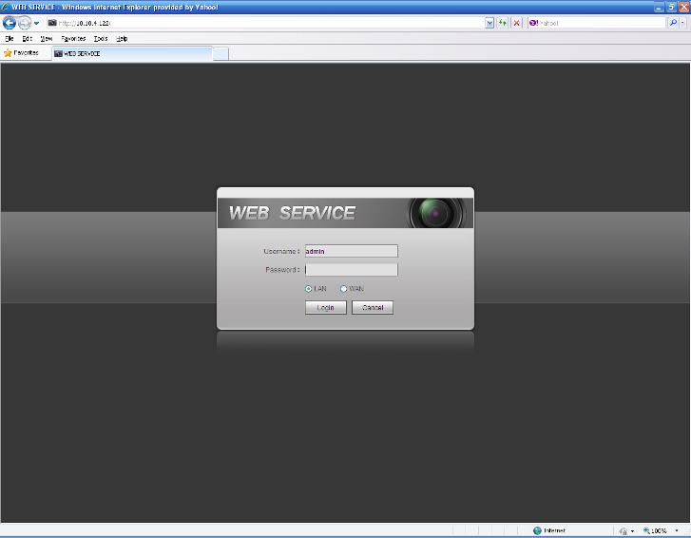
Figure 3-11

Main Window

LAN Login
For the LAN mode, after you logged in, you can see the main window. See Figure 3-12.
Click the channel name on the left side; you can view the real-time video.
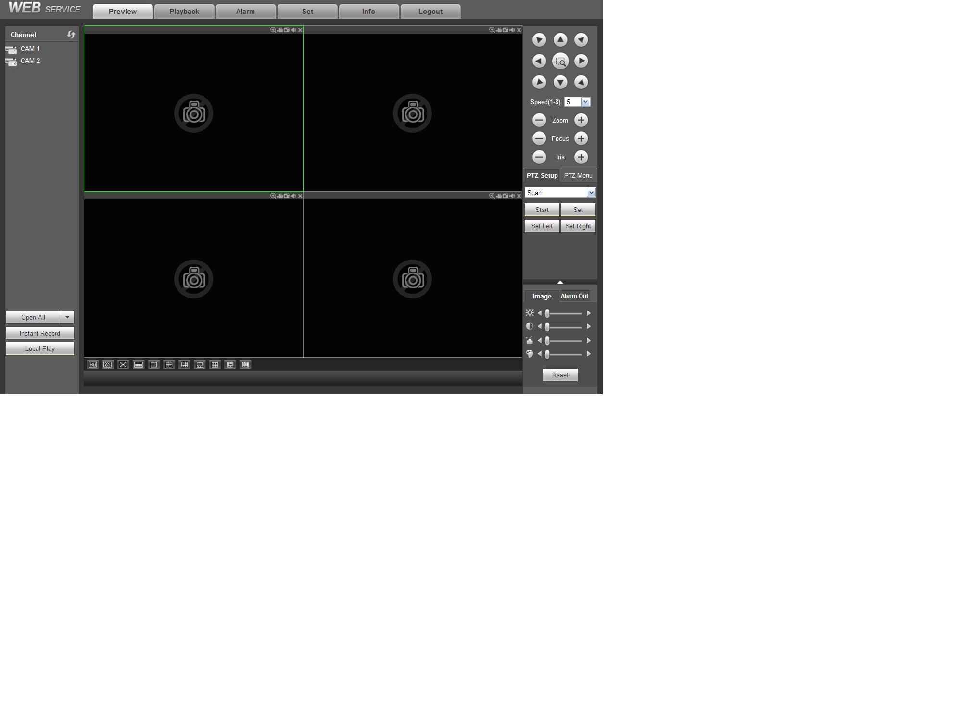
Figure 3-12

WAN Login
In WAN mode, after you logged in, the interface is shown as below. See Figure 3-13.
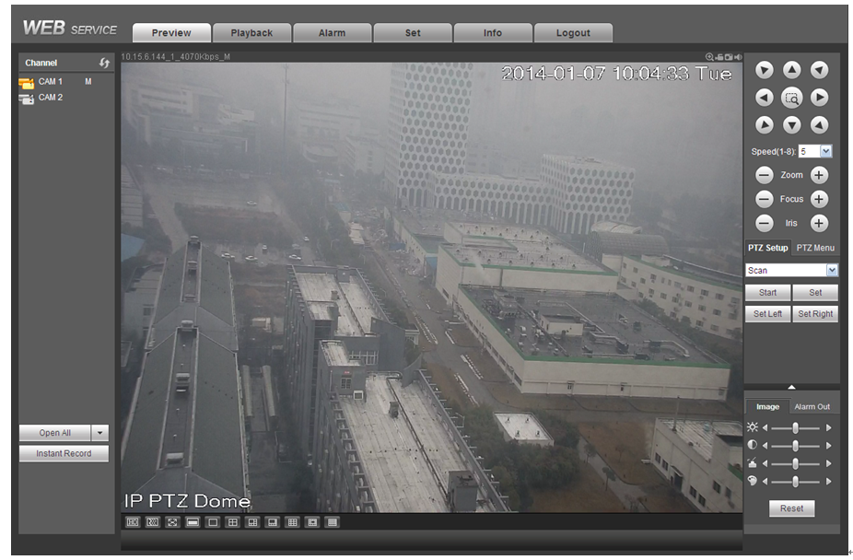
Figure 3-13
For detailed operation information, please refer to the User’s Manual included in the resources CD.

Appendix Toxic or Hazardous Materials or Elements

Component Name | Toxic or Hazardous Materials or Elements
Component Name | Pb | Hg | Cd | Cr VI | PBB | PBDE
Sheet Metal(Case) | ○ | ○ | ○ | ○ | ○ | ○
Plastic Parts（Panel） | ○ | ○ | ○ | ○ | ○ | ○
Circuit Board | ○ | ○ | ○ | ○ | ○ | ○
Fastener | ○ | ○ | ○ | ○ | ○ | ○
Wire and Cable/AC Adapter | ○ | ○ | ○ | ○ | ○ | ○
Packing Material | ○ | ○ | ○ | ○ | ○ | ○
Accessories | ○ | ○ | ○ | ○ | ○ | ○

Note
O: Indicates that the concentration of the hazardous substance in all homogeneous materials in the parts is below the relevant threshold of the SJ/T11363-2006 standard.

X: Indicates that the concentration of the hazardous substance of at least one of all homogeneous materials in the parts is above the relevant threshold of the SJ/T11363-2006 standard. During the environmental-friendly use period (EFUP) period, the toxic or hazardous substance or elements contained in products will not leak or mutate so that the use of these (substances or elements) will not result in any severe environmental pollution, any bodily injury or damage to any assets. The consumer is not authorized to process such kind of substances or elements, please return to the corresponding local authorities to process according to your local government statutes.

Note
- For detailed operation introduction, please refer to our resource CD included in your package for electronic version of the User’s Manual.
- Slight difference may be found in user interface.
- All the designs and software here are subject to change without prior written notice.
- All trademarks and registered trademarks are the properties of their respective owners.
- If there is any uncertainty or controversy, please refer to the final explanation of us.
- Please visit our website or contact your local service engineer for more information.

